Tab 1
Swaninathan et al. (2003) A perspective on distortions

Baker & Nayar (1999) A Theory of Single-Viewpoint Catadioptric Image Formation

Bogner (1995) An Introduction to Panospheric Imaging

Ward (1965) Optical Properties and Uses of the Conical Mirror

Yagi et al. (1994) Real-time omnidirectional image sensor (COPIS) for vision-guided navigation

Lin & Bajcsy (2006) Single-viewpoint, catadioptric cone mirror omnidirectional imaging theory and analysis

Lin & Bajcsy (2001) True single view point cone mirror omni-directional catadioptric system

Baker & Nayar (1999) A Theory of Single-Viewpoint Catadioptric Image Formation
- SVP is the requirement for catadioptric sensors; this paper describes all of the solutions(rotated conic sections).
- Derived fixed SVP constraint equation, solutions are planar, conical, spherical, ellipsoidal, and hyperboloidal.
- For conical mirrors, the pinhole of the camera must be at the apex of the cone, which is thus a degenerate solution.
- The circular locus lies on the cone only if the cone tip angle is 60 degrees.
- Yagi et al. (1994) and Bogner (1995).
- Derived the resolution mapping equation for hyperboloidal and ellipsoidal mirrors, should apply to conical mirrors but might not be very robust (worth giving it a try).
- Blurring analysis for hyperboloidal and ellipsoidal mirrors.

Yagi et al. (1994) Real-time omnidirectional image sensor (COPIS) for vision-guided navigation
- Conical mirror + TV camera aligned with the cone’s axis.
- Small aperture and short focal length lens.
- Installed on the robot for collision detection.
- Use trajectories of vertical edges over time as well as the azimuth direction(the angle of the robot towards the object), to compute the direction of relative motion.
- All computations in polar coordinates, no unwarping.
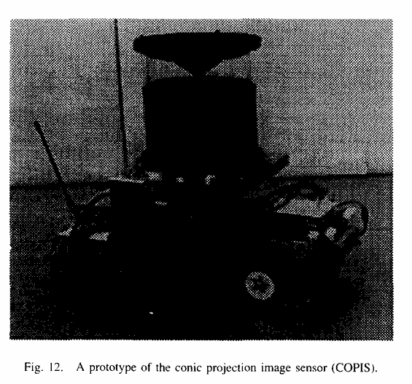

Bogner (1995) An Introduction to Panospheric Imaging
- They aim to capture a spherical field of view (360° horizontal + ≥ 180° vertical).
- Fisheye lenses + spherical/conical mirrors.
- Image Transformation Engine: LUT for pixel address imaging.
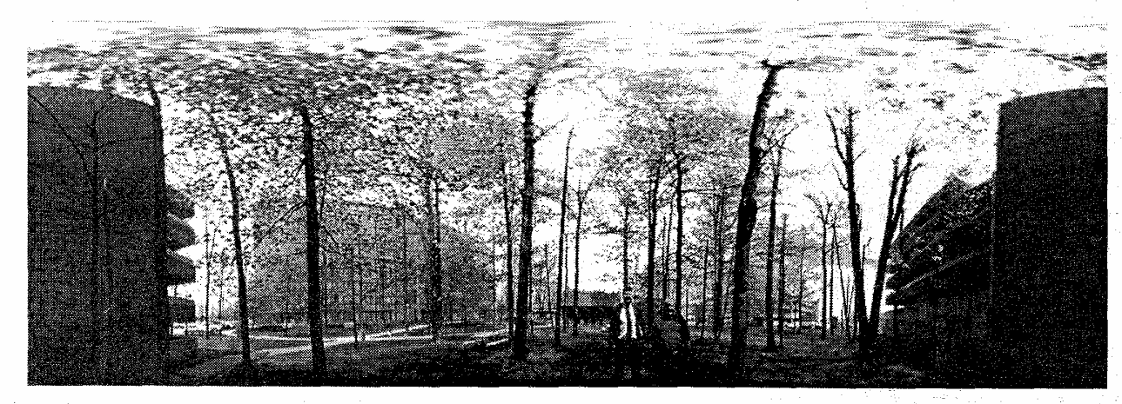
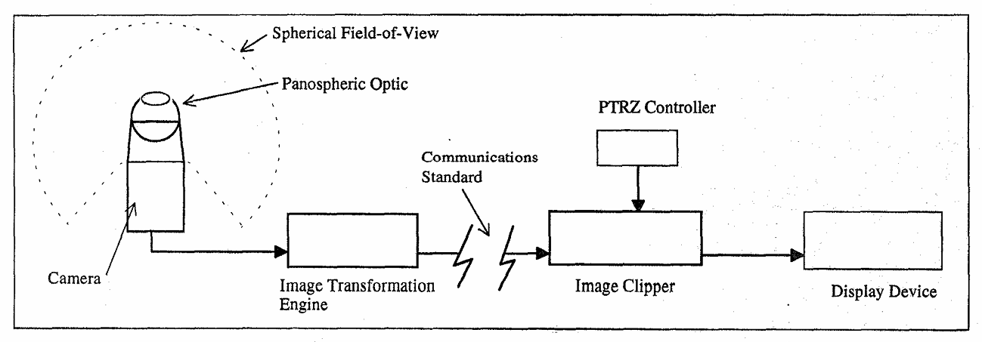

Lin & Bajcsy (2006) Single-viewpoint, catadioptric cone mirror omnidirectional imaging theory and analysis
- Detailed notes in another file.
- They proved that a conical mirror can still create SVP, which contradicts Baker & Nayar (1999).
- They provided the experiment setup in Lin & Bajcsy (2001).

Swaninathan et al. (2003) A perspective on distortions
- SVP (and approximate) can be undistorted perfectly, including a conical mirror.
- In terms of undistortion algorithms, they only derived ones for MVI (Multi-Viewpoint Image).
- Undistorting MVI requires a simple geometry primitive, with a basic uncertainty model for parameters.
- Proposed a metric to quantify distortions relative to a true perspective view.

Ward (1965) Optical Properties and Uses of the Conical Mirror
- Concave conical mirror.
- Analysis suggests not strictly SVP, but can approximate it in certain configurations.
- Derived relation between cone angle and magnification, focused on the geometric reference at the design level.

Lin & Bajcsy (2001) True single view point cone mirror omni-directional catadioptric system
- Provided the experiment setup in Fig 8, with a m12 s-mount lens.
- Provided a detailed unwarping algorithm in section 4.
- Removing a small amount from the tip does not affect the geometry, but only slightly affects the brightness.

